Airline Passenger Satisfaction

Are you looking to boost passenger satisfaction and increase profits for your airline? Look no further than your business class passengers and potential business class passengers. With 70% of your total profit coming from these passengers, it's clear that they're crucial to your success.

To understand how to better serve these valuable customers, we've analyzed the 'US Airline passenger satisfaction' dataset from 2015. This dataset includes ratings of 14 air travel services as well as additional information about each passenger, such as their class and type of travel. The 14 ranked services include airline backoffice services, airport services, in-flight-services and on-board-infrastructure.

Our analysis revealed a key insight: Individuals traveling for work are significantly less satisfied in economy class than those traveling for personal reasons. However, these same business travelers are more satisfied in business class than those traveling for personal reasons. This suggests that the needs of work travelers are not being fully met in economy class, but upgrading to business class offers a better experience.

Our aim is to identify which services should be marketed to work travelers flying economy class to convince them to upgrade to business class. By doing so, we can enhance passenger satisfaction and drive profits for your airline.

To determine which airline services to market, we compared passenger satisfaction of the airline services between economy and business class. We evaluated 14 different services and calculated the percentage of passengers who were satisfied or very satisfied (rated 4 or 5 on a scale) in each class. Then, we compared the proportions between economy and business class for each service to identify the largest differences.

Our analysis enabled us to identify the services with the most significant gaps in satisfaction levels between the two classes. And the services with the most difference are the one that should be marketed to work travelers in economy class to convince them to upgrade to business class.

We presented our findings in a plot, where services are ranked by the size of the difference in satisfaction levels between economy and business class. The services at the far left of the plot indicate the greatest differences and therefore provide the most promising marketing contents.

Old

Do you want to turn new passengers into returning passengers by increasing passenger satisfaction? And thus increase the profits of your airline?

To find out which services should be marketed by the airlines, we compared the satisfaction rankings of the services of economy class passengers with those of the business class. For each service, we calculated the percentage of satisfied and very satisfied passengers, in other words those passengers who chose 4 or 5 on the scale, in economy and business class. Then we subtracted the proportion of economy from business to find out how big the difference is.

The aim here is to identify the services with the greatest differences between Economy and business class. These services should be communicated to work travelers in economy.

In our final plot, all 14 services are listed and sorted by the size of the difference in satisfied and very satisfied passengers between Economy and Business. This means that the services shown on the far left of the plot show the biggest differences between Eco and Business and should therefore be used for marketing.

Economy and Business and to include the general satisfaction level in the calculation. The greater the difference between Eco and Business, the higher the potential to convert a less satisfied passenger in Eco Class to a more satisfied passenger in Business Class.

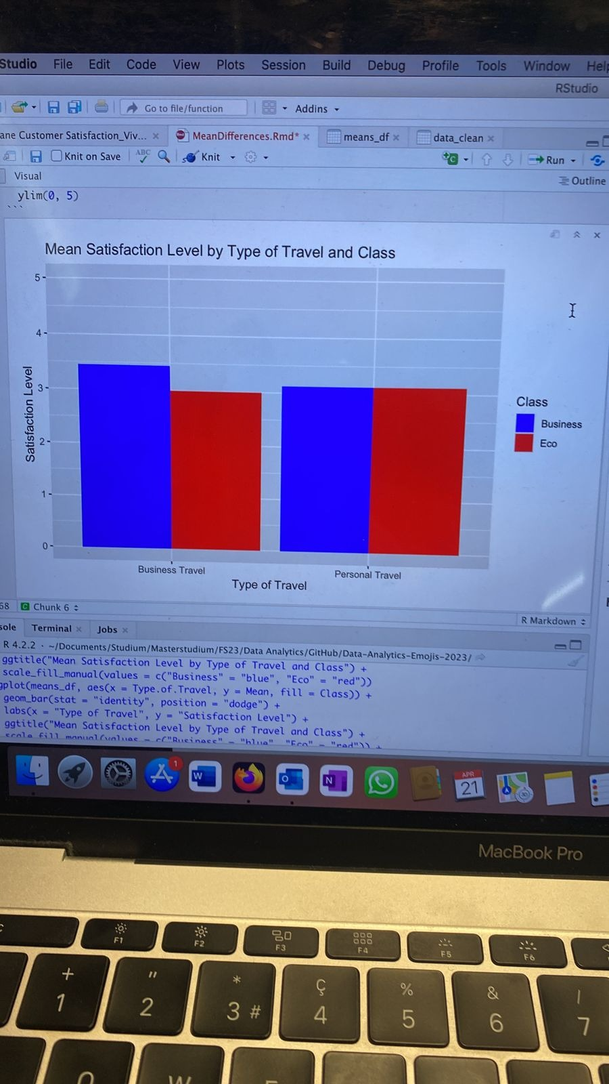

Methods:

* NA’s for each satisfaction variable: between mind. 0% ; max: 5.14% (mean: 0.8%)

OLD IDEAS

Airline Passenger Satisfaction

**Research Question** (Marketing)

What aspects should the airline market to convince business travelers to upgrade from economy to business class?

**Rational**

Increase profit for the airline. Business class was built to satisfy the need of business travelers. Business travelers make up to 75% of the annual airline profit because they are flying business or first class. On average the price of a business class ticket is four times the price of an economy ticket.

<https://www.farecompare.com/travel-advice/business-class-when-is-it-worth-the-cost/>

**Method**

* Variables:
  + Subset with only business travelers
  + Convert 0 to NA
  + Group variable: economy class vs. Business class (‘Class’)
  + 14 satisfaction variables
* RQ:
  + Are there sig differences in the distributions? In which directions are the differences? The aspects relevant for marketing are those distribution differences where business class has a higher satisfaction level than economy class.
* Method:
  + Plot for each variable (14) the satisfaction distribution for economy and business class passengers
  + Histogram? Boxplot? Violin plot? T-test? F test? <https://towardsdatascience.com/how-to-compare-two-or-more-distributions-9b06ee4d30bf>

**Next steps**

* Subset vom Dataset bilden ‘Data Wrangling’
  + Rauswerfen: ID, overall satisfaction, loyal/disloyal, type of travel ==’personal travel’, departure delay, arrival delay
  + Data0: with 0
  + Data1: without 0 🡪 nicht ganze Person, sondern nur bei der jeweiligen Variablen
* Zusatzanalysen:
  + 0 systematic und in Worten präsentieren
  + Unterschied zw. Economy & economy plus?
* Group: economy vs. Business (mit oder ohne economy plus)
* Plot distributions for each variable (14). Significant differences?

**Key Take-aways from Meeting (14th April)**

🡪 Send RMarkdown as a html file (knit)

🡪 Hide some codes – only show the important codes (e.g. visualization)

Pitch

* Aim, specific question, data set, method, implication
* Example: The service in Business Class is already good we don’t want to change it but the people in economy class are not aware of these benefits, and we want to make them aware of these services (marketing)
* Also include the other travelers (private reasons)🡪 do they differ from those that travel for work
  + Difference between work travelers and private travelers in their overall satisfaction score (mean) for Economy vs. Business class
    - meanWorkEconomy vs. meanPrivatEconomy 🡪 erwarten höhere Zufriedenheit mit Economy class für Private travelers 🡪 economy class deckt die Bedürnfisse der Work travelers nicht deshalb sollen sie wechseln
    - meanWorkBusiness vs. meanPrivatBusiness 🡪 erwarten höhere Zufriedenheit mit Business class für Work travelers because business class is designed fort hem

Visualization

Aim: Feature selection for marketing! (patterns over significances). We want to show which variables we want to push and which ones not 🡪 that is our visualization!

Calculate mean percentage of NA’s for each variable (should be around 5% - 10%)

* Include all satisfaction variables
* Maybe also a distribution plot for each variable (violine) (Abb.1)
* Difference plots (delta): Abb. 2
  + Delta = meanB – meanE for each variable
  + Delta = ProportionB 4,5 vs. 1,2,3 – ProportionE 4,5 vs. 1,2,3

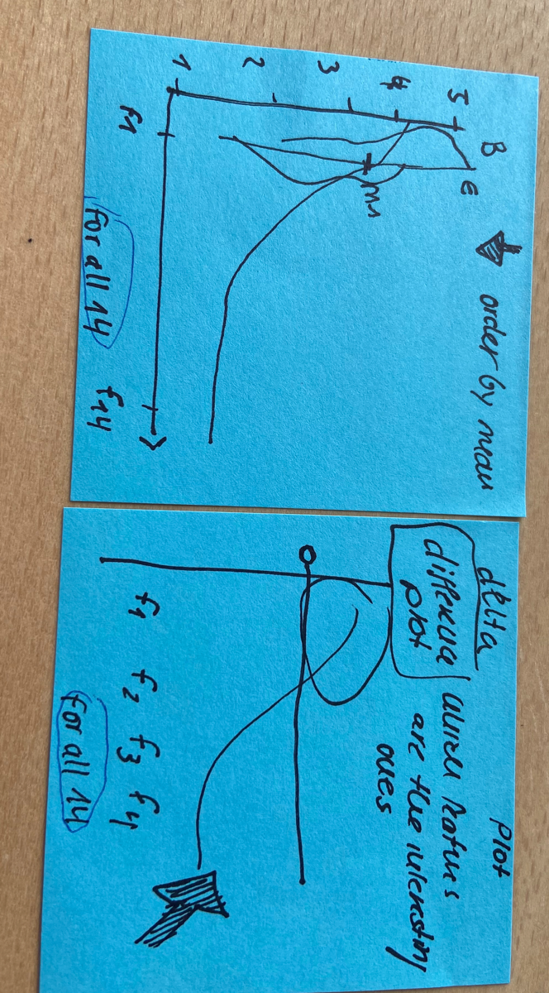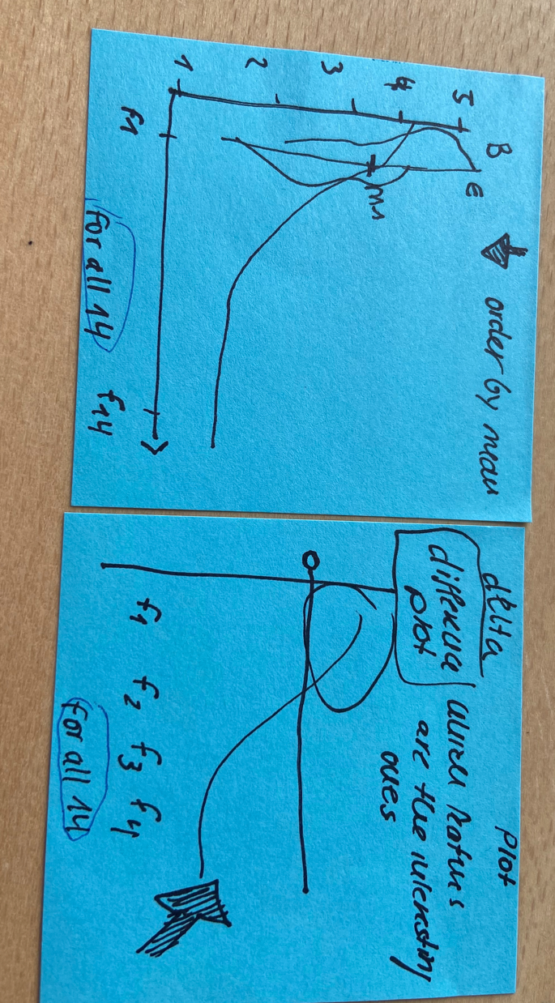

Abbildung 2

Abbildung 1

On.board.service, Baggage.handling, Checkin.service, Inflight.service, Inflight.wifi.service, Departure.Arrival.time.convenient, Ease.of.Online.booking, Gate.location, Food.and.drink, Inflight.entertainment, Cleanliness, Leg.room.service